BUSINESS INSIGHT REPORT
Dataset: GLOBAL SALES & FINANCIAL PERFORMANCE
Interactive Sales Dashboard Analysis
Student Name:
JAGANATHAN A

1. Introduction
This report presents a comprehensive business insight analysis derived from the Global Sales & Financial Performance dataset, visualized through an interactive Power BI sales dashboard. The purpose of this report is to translate raw sales, profit, and operational data into meaningful, actionable business intelligence.
The analysis covers overall company performance through key performance indicators (KPIs), sales distribution across product categories and regions, monthly sales trends, and individual employee performance. The insights presented are intended to support data-driven decision-making in areas such as inventory planning, marketing strategy, regional expansion, workforce management, and customer targeting.

2. Dashboard Overview
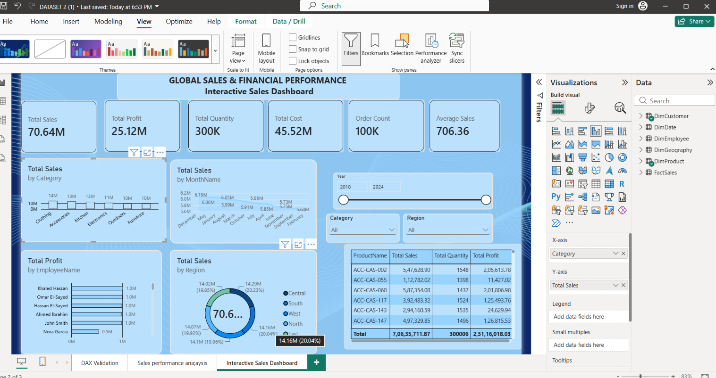
The screenshot above presents the full Interactive Sales Dashboard, built in Power BI, titled "Global Sales & Financial Performance." It consolidates company-wide KPI summary cards, a category-level sales breakdown, a monthly sales trend chart, a regional sales donut chart, an employee profit comparison, and a detailed product-level data table, alongside interactive filters for Year, Category, and Region. This single-page view enables stakeholders to monitor overall performance and drill into specific dimensions of the business in real time.

4. KPI Analysis
The dashboard's key performance indicator cards summarize the overall health of the business across the analyzed period:
• Total Sales: 70.64M — the total revenue generated across all product categories, regions, and time periods.
• Total Profit: 25.12M — representing a healthy profit margin of approximately 35.6% of total sales.
• Total Quantity: 300K units sold, reflecting strong overall sales volume.
• Total Cost: 45.52M — the cost of goods sold, which is the primary driver against which profit is measured.
• Order Count: 100K orders processed, indicating a large and active customer base.
• Average Sales: 706.36 per order, a useful benchmark for evaluating average transaction value.
Overall, the ratio between total sales (70.64M) and total cost (45.52M) indicates efficient cost management, yielding a solid profit margin. This positions the business favorably, though the relatively modest average sales value per order (706.36) suggests opportunities to grow through increased basket size rather than customer acquisition alone.
TOTAL SALES  70.64M | TOTAL PROFIT  25.12M | TOTAL QUANTITY  300K
TOTAL COST  45.52M | ORDER COUNT  100K | AVERAGE SALES  706.36

5. Product Category Performance Analysis
The 'Total Sales by Category' chart breaks down revenue across six product categories: Clothing, Accessories, Kitchen, Electronics, Outdoors, and Furniture.
• Clothing leads all categories with approximately 14M in sales, making it the strongest-performing product line.
• Accessories and Kitchen follow closely behind, each contributing around 13M in sales, indicating these categories are similarly strong secondary revenue drivers.
• Electronics and Outdoors each generate approximately 10-11M, positioning them as solid but comparatively moderate performers.
• Furniture generates the lowest sales of the six categories at approximately 10M, suggesting either lower demand or pricing/inventory constraints.
The relatively narrow spread between the highest and lowest performing categories (roughly 14M to 10M) indicates a well-diversified product portfolio, with no single category being overwhelmingly dominant or critically underperforming. This balance reduces business risk associated with over-reliance on one category.

6. Monthly Sales Trend Analysis
The 'Total Sales by MonthName' chart tracks monthly revenue across the calendar year, with values ranging narrowly between approximately 5.60M and 6.20M per month.
• December records the highest monthly sales at approximately 6.2M, likely driven by holiday and year-end seasonal demand.
• February shows the lowest monthly sales at approximately 5.60M, consistent with a typical post-holiday slowdown.
• Mid-year months (May through August) maintain relatively stable performance in the 5.85M-6.06M range, showing consistent demand through the summer period.
• Autumn months (September through November) show a mild dip, trending toward the low end of the range before recovering into December.
Overall, monthly sales remain fairly consistent throughout the year (a variance of less than 11% between the highest and lowest months), indicating low seasonality risk. However, the clear December peak and February trough suggest an opportunity to plan targeted promotions and inventory buildup ahead of the holiday season and design stimulus campaigns to offset the early-year slowdown.

7. Regional Sales Analysis
The 'Total Sales by Region' donut chart shows total sales of 70.6M distributed across five regions: Central, South, West, North, and East.
• South leads with 14.29M in sales (20.23% of total), making it the top-performing region.
• North follows closely with 14.16M (20.04%).
• East contributes 14.10M (19.96%).
• West contributes 14.07M (19.92%).
• Central records the lowest regional contribution at 14.02M (19.85%).
The regional distribution is remarkably even, with each region contributing close to a fifth (20%) of total sales. This balanced geographic spread suggests the business has achieved strong market penetration across all operating regions, with no single region acting as a bottleneck or over-concentration risk. The slight lead held by the South region could be studied further to replicate its success in the marginally lower-performing Central region.

8. Employee Performance Analysis
The 'Total Profit by EmployeeName' chart compares profit contributions across six employees: Khaled Hassan, Omar El-Sayed, Hassan El-Sayed, Ahmed Ibrahim, John Smith, and Nora Garcia.
• Khaled Hassan, Omar El-Sayed, Hassan El-Sayed, Ahmed Ibrahim, and John Smith each contribute approximately 1.0M in profit, forming a tightly-clustered group of top performers.
• Nora Garcia contributes noticeably less, at approximately 0.5M in profit, roughly half the contribution of the other five employees.
Five of the six employees are performing at a consistent, strong level, which reflects positively on overall sales team effectiveness and training standards. The visible gap in Nora Garcia's performance stands out as an area worth investigating further, whether due to territory assignment, tenure, product mix, or other factors, so that targeted coaching or support can help close the gap.
Top Product Performance (from Dashboard Data Table)
Product Name | Total Sales | Total Quantity | Total Profit
ACC-CAS-002 | 5,47,628.90 | 1,548 | 2,05,613.78
ACC-CAS-055 | 1,12,782.02 | 1,398 | 11,427.02
ACC-CAS-060 | 5,87,354.08 | 1,437 | 2,01,806.98
ACC-CAS-117 | 3,92,483.32 | 1,524 | 1,25,493.76
ACC-CAS-143 | 2,94,160.59 | 1,535 | 24,629.94
ACC-CAS-147 | 4,97,329.85 | 1,496 | 1,26,815.53
Total | 7,06,35,711.87 | 300,006 | 2,51,16,018.03

The product-level table highlights that ACC-CAS-060 and ACC-CAS-002 deliver the strongest profit relative to sales, while ACC-CAS-055 generates comparatively low profit despite reasonable sales volume, indicating a thinner margin on that item worth reviewing.

9. Business Recommendations
Based on the dashboard analysis above, the following recommendations are proposed to help drive continued business growth and operational efficiency:
Inventory Planning
• Increase inventory allocation for Clothing, Accessories, and Kitchen ahead of peak periods, since these categories consistently generate the highest sales.
• Build up stock levels in October and November in anticipation of the December sales peak, and plan lean inventory for the January-February slowdown to reduce holding costs.
Marketing Strategy
• Launch targeted promotional campaigns in January and February to counteract the seasonal dip observed following the December peak.
• Bundle lower-performing Furniture products with high-performing categories such as Clothing or Kitchen to lift average order value.
Regional Expansion
• Since regional sales are already well balanced (each region contributing close to 20%), prioritize investment in the South region's proven strategies and replicate them in the Central region, which currently trails slightly.
• Explore expansion into new geographic markets, as the current five regions are all performing at a mature, similar level with limited room for further internal rebalancing.
Employee Performance
• Provide targeted coaching, mentoring, or territory review for Nora Garcia to help close the profit-contribution gap with the rest of the sales team.
• Recognize and formalize the practices of the top five consistent performers (Khaled Hassan, Omar El-Sayed, Hassan El-Sayed, Ahmed Ibrahim, and John Smith) as best-practice case studies for onboarding new staff.
Product Portfolio
• Review the Furniture category's pricing, supplier costs, and marketing support, since it is the lowest-performing category and may benefit from a refreshed strategy or portfolio rationalization.
• Expand the highest-margin products within the Accessories category (such as ACC-CAS-002 and ACC-CAS-060, which show strong profit-to-sales ratios in the product table) to maximize profitability.
Customer Targeting
• Use the relatively low average sales value (706.36 per order) as a basis for cross-sell and upsell campaigns aimed at increasing basket size among the existing 100K-order customer base.
• Segment customers by region and category preference to deliver more personalized offers, leveraging the balanced regional data already captured in the dashboard.

